YB-)
:) Hai guys. Good day for you.
This is my very first tutorial. First I thank my master Boysie for permit me to write a tutorial.
This is a tutorial for NOobs to mod their phone.
BTW, what is modding?
Modding is nothing but hacking your phone :p
And I’m going to show you how to hack your phone.
Requirements:
1. Mobile Phone
2. PC
3. Data Cable
4. USB Flash Driver
5. Farmanager With SEFP2 Plugin.
Step-1:
Download Flash Driver and Farmanager + SEFP2 Plugin from the above link and extract them. Install GGate flash driver in your pc and extract farmanager. Now you can find the Far.exe inside the extracted Farmanager folder. Open it and now you can see the Farmanager window likes below
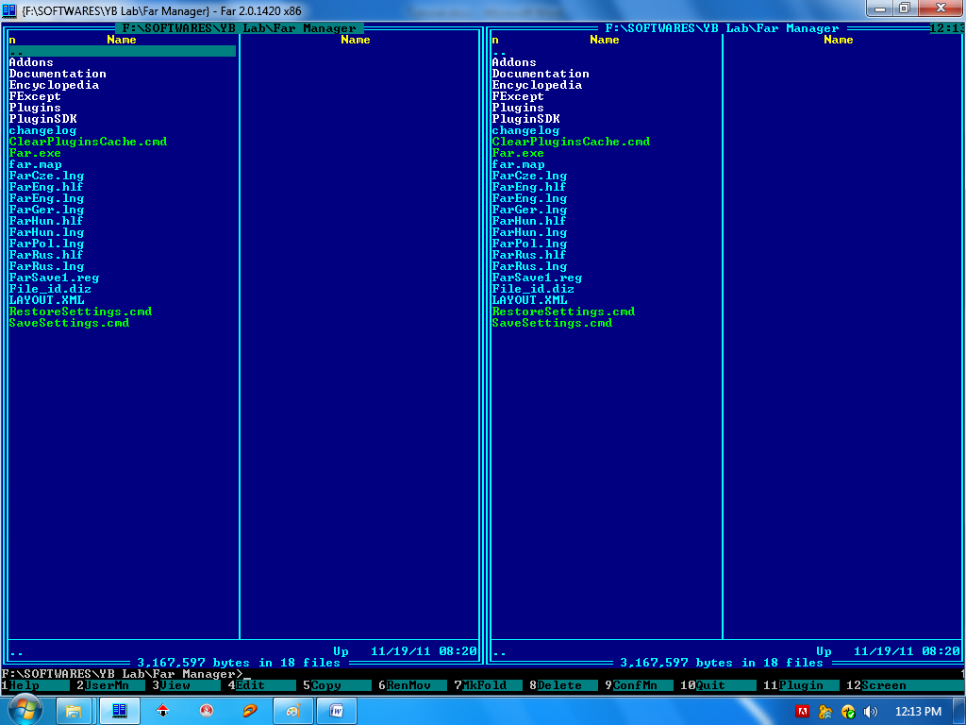
Step-2:
Press Alt+F1 and a new window pop-up. Select SEFP2 or press 0(Zero) then click on connect or press C. Now the screen is likes this
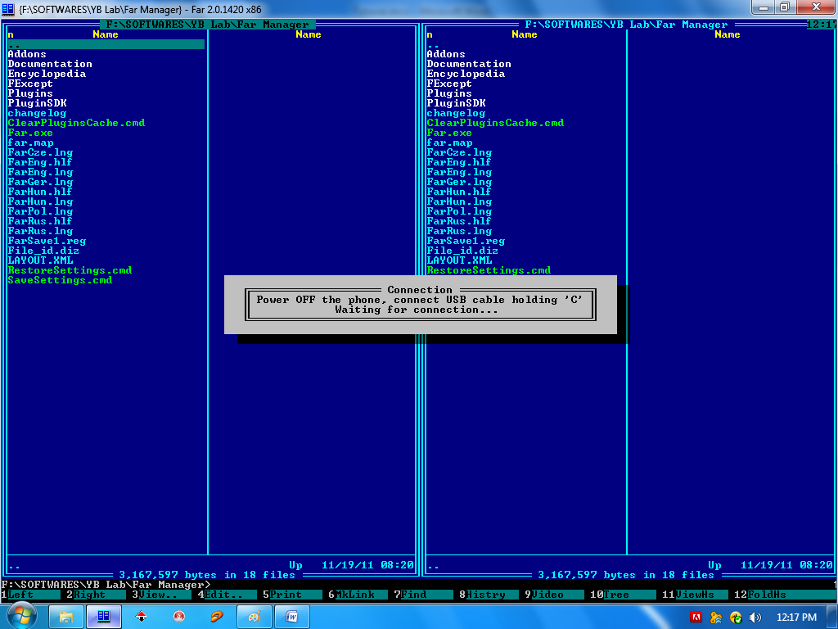
Now the farmanager is ready to connect with your phone.
Step-3:
Switch off your phone, remove and reinsert the battery and connect it to PC by holding C(Clear) button in your phone. If the clear button is not working then press 2 & 5 together in your phone. After connected the screen looks like this
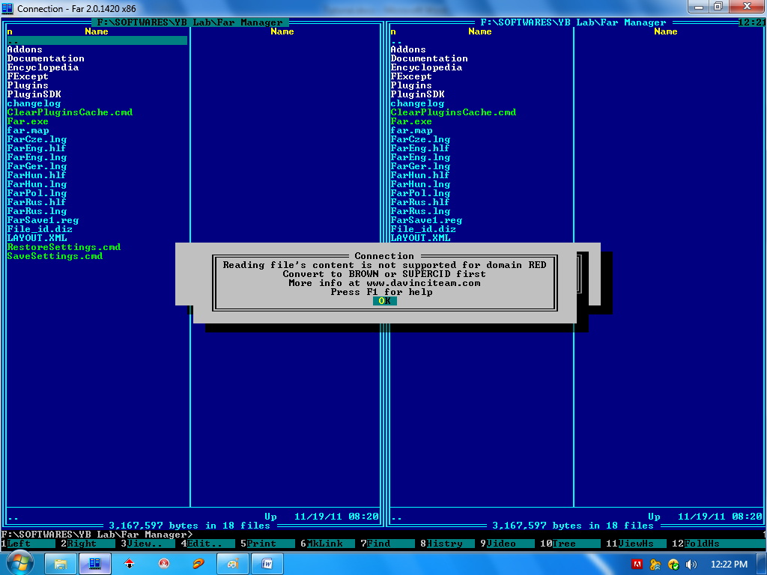
Don't bother about the error message. Its just a warning message that, you have to convert your phone into brown or super cid for read the contents of your file system. It will confuse you.
So just press ok on that error.
Step-4
That's it. You made it :party:
Yes, Now you are inside your phone's file system. The screen looks like this
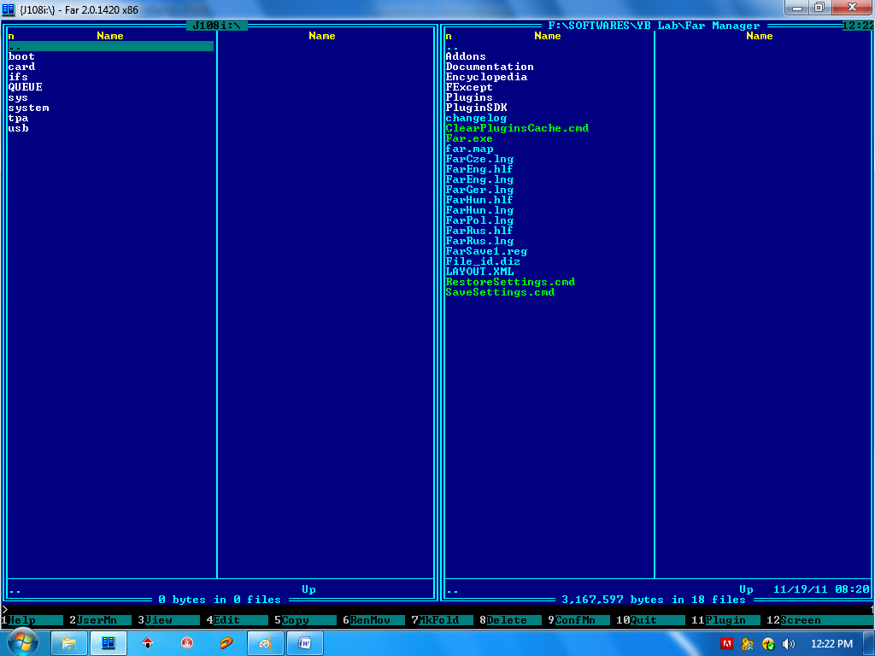
The left panel is phone's file system and the right panel is your PC.
You can explore your FS an PC by clicking the folders and files. Use ".." to go back.
Now, We are crossed the most important steps in modding successfully.
--------------------------------
:confused: What types of modding are possible in DB3350 phones?
Let me clear you.
1. Changing the acoustic files (Sound drivers) for better music performance.
2. Changing the Camera & Display drivers.
3. Changing the ic (icon and graphics) file to make your phone looks cool.
4. Changing layouts, fonts, installing flash themes and do some changes in the phone firmware using .xml files are some minor moddings.
Changing Acoustics:
For changing acoustics, you need good acoustic files. Everyone have different taste on music. So there its up to you.
Put .wbxml files in ifs/settings/acoustics and .csv files in tpa/preset/acoustics.
Changing Camera driver and Display driver:
For changing camera & display driver, you need a correct camera & display driver for your phone.
Put Camdriver0.dat file into ifs/settings/camera and Dispdriver0.dat into ifs/settings/display.
Changing IC files:
IC files contains all the icons used in your phone. DB3350 v2 phones are using "sunny_susan_semc_icon_graphics_main_0.ic” icon files as ic. Whereas Yari & Aino are using "frida_semc_icon_graphics_main_0.ic" & "hb2_09_wqvga_semc_icon_graphics_main_0.ic" as icon files respectively. Also it's not recommended to use Yari and Aino's.ic files on DB3350v2 phone as some images in Walkman settings and Camera are missing.
Put that modded ic file in tpa/preset/system/icons
Changing Fonts:
Download fonts and rename them into Universal-Reg.ttf, Universal-Ital.ttf, Universal-Bold.ttf, Universal-BdIt.ttf. and put those 4files into tpa/preset/system/fonts. If you find only one file of any font, then don’t worry. Just make four copies and rename them :p
Adding Flash Menus:
It makes your phone to look charm. Download flash menus in our download section and put all .swf files into tpa/preset/system/desktop/flash. Copy .thm files in your phone or memory card. After finishing your works, press F10 to quit from farmanager. Then reinsert your battery and turn on your phone.
-----------------------------------
Ahw! My fingers are :censored: paining. Hope this will be helpful for Noobs. For further doubts, feel free to ask here. We are ready to help.

